Dual-Pivot Quicksort
LIN Zhanzhi

Abstract — This project presents a modern C++17 dual‑pivot quicksort library as a practical drop‑in alternative to std::sort for in‑memory sorting on shared‑memory CPUs. It combines Yaroslavskiy’s dual‑pivot partitioning with median‑of‑five sampling, mixed insertion sort for small subarrays, Dutch National Flag handling of duplicates, and an introspective heapsort fallback. Adaptive extensions include Timsort‑style run detection and merging and counting‑sort specializations for 8‑ and 16‑bit integer types. A custom benchmarking framework spanning over 7,800 configurations shows that the implementation matches or slightly exceeds std::sort on random inputs, achieves up to ~19× speedup on structured data, and attains 5.76× speedup on 16 threads for 10 million integers with a custom work‑stealing thread pool.
Keywords — Dual-pivot quicksort, adaptive sorting, work-stealing, C++17, performance analysis

Introduction
Sorting remains a fundamental systems operation, but existing C++ standard library implementations still rely mainly on single-pivot Introsort despite the practical success of dual-pivot quicksort in Java [1][2]. The core motivation of this project is to determine whether Yaroslavskiy’s reduction in scanned elements and memory traffic can translate into real wall-clock speedups in native C++ code, where comparator overhead is already very low. The project therefore targets both algorithm engineering and empirical validation: building a production-quality implementation, benchmarking it rigorously against GCC std::sort, and explaining the observed performance at the hardware level [3].

design and implementation
- Header-only C++17 library; generic over random-access iterators and usable as a drop in replacement for std::sort.
- Sequential core: dual‑pivot three‑way partitioning, median‑of‑five sampling, mixed insertion sort for small subarrays, and introspective heapsort fallback for worst‑case safety [4].
- Adaptive paths: Timsort‑style run merger for structured inputs and counting‑sort specializations for int8_t/int16_t to exploit small key ranges.
- Parallelization: custom work‑stealing thread pool with per‑worker mutex‑protected deques (local LIFO pops, remote FIFO steals) and a sticky‑victim policy to reduce steal overhead [5].
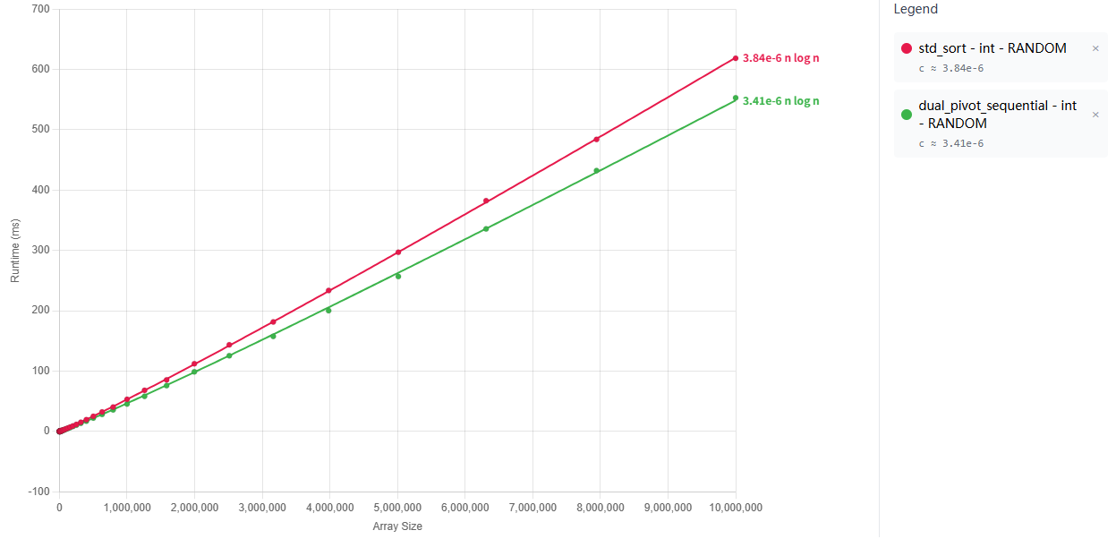
Fig. 1. Runtime comparison of sequential Dual-Pivot Quicksort and std::sort on random 32-bit integers.
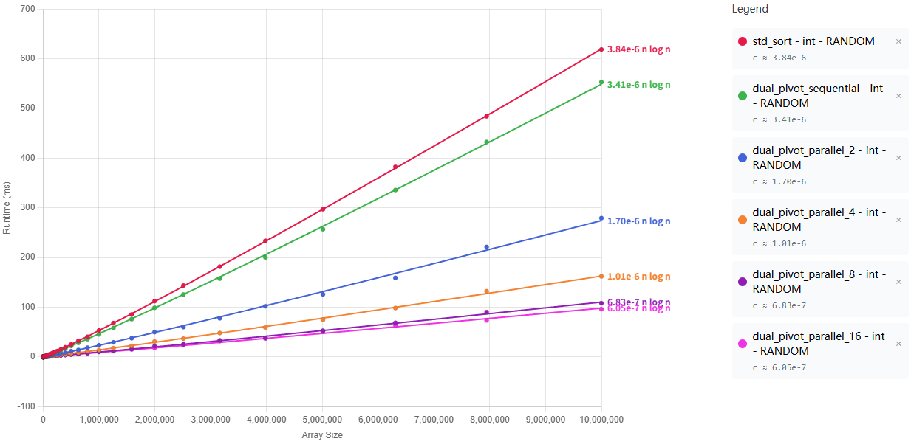
Fig. 2. Runtime on random integers for std::sort and Dual-Pivot Quicksort with 1, 2, 4, 8, and 16 threads.

evalauation and Results
Fig. 1 shows that the sequential dual-pivot implementation is competitive with std::sort on random 32-bit integers, while additional experiments (not shown) demonstrate much larger gains—up to about 19×—on highly structured, run-rich inputs due to the Timsort-style run merger.
Fig. 2 reports the parallel scaling on random integers: Dual-Pivot Quicksort reaches a 5.76× speedup at 16 threads for 10 million elements, but scaling flattens beyond 8 threads. Intel VTune analysis attributes this plateau to the memory wall rather than algorithm design, with most pipeline slots at high thread counts lost to cache-miss stalls, branch mispredictions, and front-end limitations.

conclusion
This project demonstrates that dual-pivot quicksort can be engineered into a practical, modern C++ sorting library with strong real-world performance. Its main contributions are a robust generic implementation, adaptive optimizations for structured and bounded-range inputs, a custom work-stealing parallel runtime, and a detailed hardware-level evaluation explaining where speedups come from and where they stop. Future work identified in the report includes SIMD vectorization, block-based partitioning inspired by BlockQuicksort, and improved handling of nearly-sorted inputs.

References
- C. A. R. Hoare, Quicksort, The Computer Journal, Volume 5, Issue 1, 1962, Pages 10–16, https://doi.org/10.1093/comjnl/5.1.10.
- V. Yaroslavskiy, “Dual-Pivot Quicksort,” 2009.
- D. R. Musser, "Introspective sorting and selection algorithms," Software: Practice and Experience, vol. 27, no. 8, pp. 983–993, Aug. 1997, doi: 10.1002/(SICI)1097-024X(199708)27:8<983::AID-SPE117>3.0.CO;2-#.
- M. E. Nebel, S. Wild, and C. Martínez, "Analysis of pivot sampling in dual-pivot quicksort: A holistic analysis of Yaroslavskiy’s partitioning scheme," Algorithmica, vol. 80, no. 2, pp. 790–848, Jun. 2016.
- R. D. Blumofe and C. E. Leiserson, "Scheduling multithreaded computations by work stealing," Journal of the ACM, vol. 46, no. 5, pp. 720–748, Sep. 1999.

